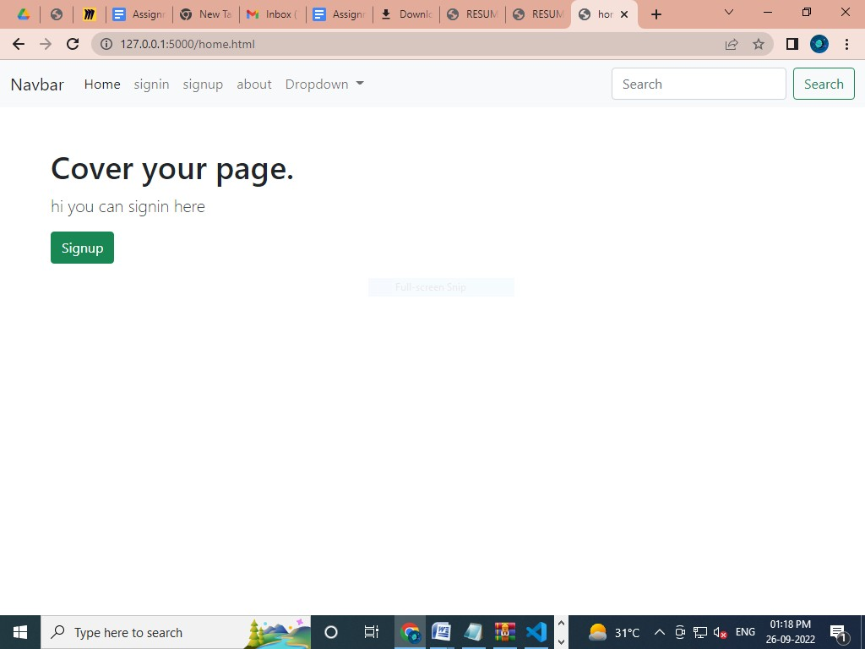
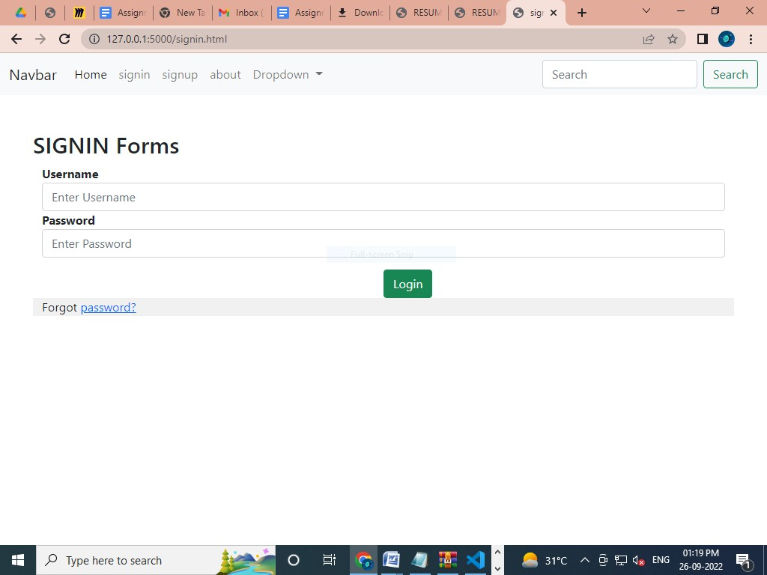
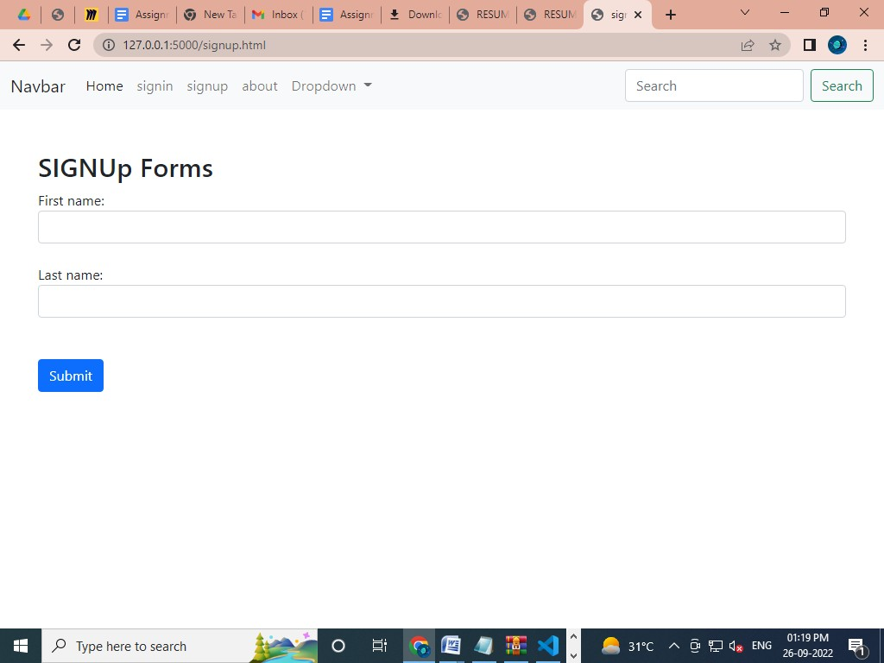
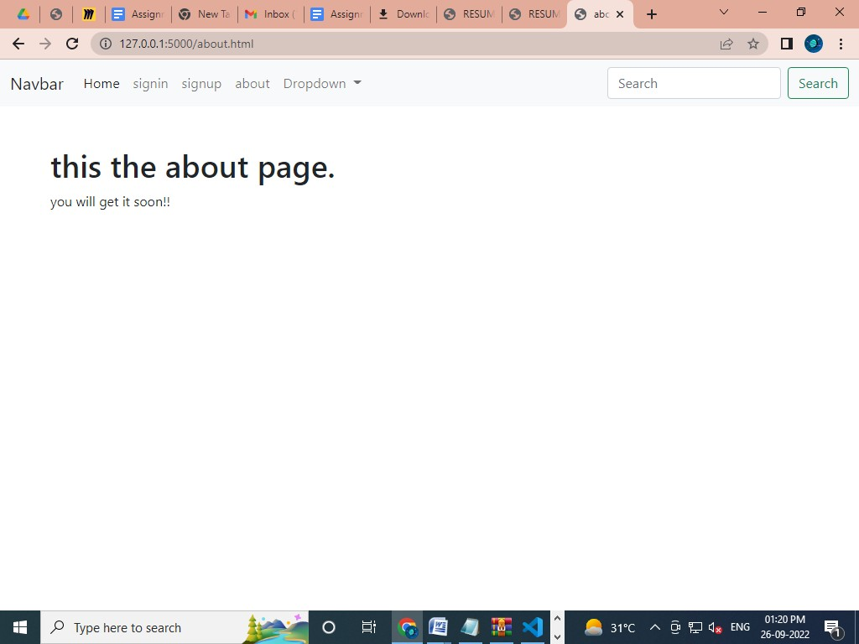
Assignment -2

Assignment Date | 27 September 2022
Student Name | SYED ABDUL RAHMAN S
Student Roll Number | 110119104077
Maximum Marks | 2 Marks

Question-1:
- Create a Flask App
- Add the Home page, About Page
- Add the Bootstrap
- Add the Sign in page and App the Signup Page

Solution:
app.py: | from flask import Flask,render_template,request,url_for,redirect,flash from markupsafe import escape  app=Flask( name__) @app.route("/")  def index():  return render_template("home.html")  @app.route("/home.html") def hello():  return render_template("home.html")  @app.route("/about.html") def profile():  return render_template("about.html")  @app.route("/signup.html") def signup():  return render_template("signup.html")  @app.route("/signin.html") def signin():

Templates: Home page

Base page

<!-- <link rel="stylesheet" href="{{url_for('static', filename='css/style.css')}}"> -->
{% block head%}{% endblock %}

</head>
<body>

<nav class="navbar navbar-expand-lg navbar-light bg-light">
<div class="container-fluid">
<a class="navbar-brand" href="#">Navbar</a>
<button class="navbar-toggler" type="button" data-bs- toggle="collapse" data-bs-target="#navbarSupportedContent" aria- controls="navbarSupportedContent" aria-expanded="false" aria-label="Toggle navigation">
<span class="navbar-toggler-icon"></span>
</button>
<div class="collapse navbar-collapse" id="navbarSupportedContent">
<ul class="navbar-nav me-auto mb-2 mb-lg-0">
<li class="nav-item">
<a class="nav-link active" aria-current="page" href="home.html">Home</a>
</li>
<li class="nav-item">
<a class="nav-link" href="signin.html">signin</a>
</li>
<li class="nav-item">
<a class="nav-link" href="signup.html">signup</a>
</li>
<li class="nav-item">
<a class="nav-link" href="about.html">about</a>
</li>
<li class="nav-item dropdown">
<a class="nav-link dropdown-toggle" href="#" id="navbarDropdown" role="button" data-bs-toggle="dropdown" aria- expanded="false">
Dropdown
</a>
<ul class="dropdown-menu" aria- labelledby="navbarDropdown">
<li><a class="dropdown-item" href="#">Action</a></li>
<li><a class="dropdown-item" href="#">Another
action</a></li>

here</a></li>

<li><hr class="dropdown-divider"></li>
<li><a class="dropdown-item" href="#">Something else

About page

Signin page

Signup page

Output

Homepage:

Signin page:
signup page:
About page:

